You are Cordially Invited to Attend the

The Columbus Forum’s
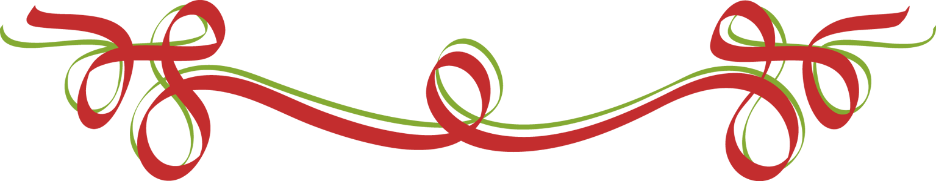

End of the Year

“Meet & Greet”

All are welcome!!
Members bring a friend!

(If an eligible non-member attends, becomes a member,
and pays dues that night, they come free of charge)

Tuesday, June 13, 2017

Hors d’oeuvres

Wine, Beer & Soda

5:30 p.m. ~ 7:30 p.m.

Come and get to know us

NOIR Restaurant

1909 E. Passyunk Avenue
(Street/Meter Parking)

$25 per person

Please RSVP By Wednesday, June 8th to Renee Novello
via email – justawrite@aol.com or text - 267-688-4881

Cash/Make checks payable to: Columbus Forum #1492

Visit us at: columbusforum.org
Like us on Facebook: Columbus Forum Lodge 1492
Follow us on Twitter: Columbus Forum Lodge @columbusforumpa

